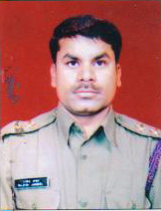

I, Dr.Rajesh Janghel, feels that Pt.Harishankar Shukla College is one of the best colleges in this region in the field of Physical Education. This college has not only given various students who stood positions in the merit of university but also the students who got medals in various sports across the country. This college has a mini gymnasium where the students can get fitness and I am sure that this college has a very bright future.

Dr. Rajesh Janghel (HOD)
Department of Physical Education

